NATIONAL ECOLOGY COMMISSION  MEMBERS | 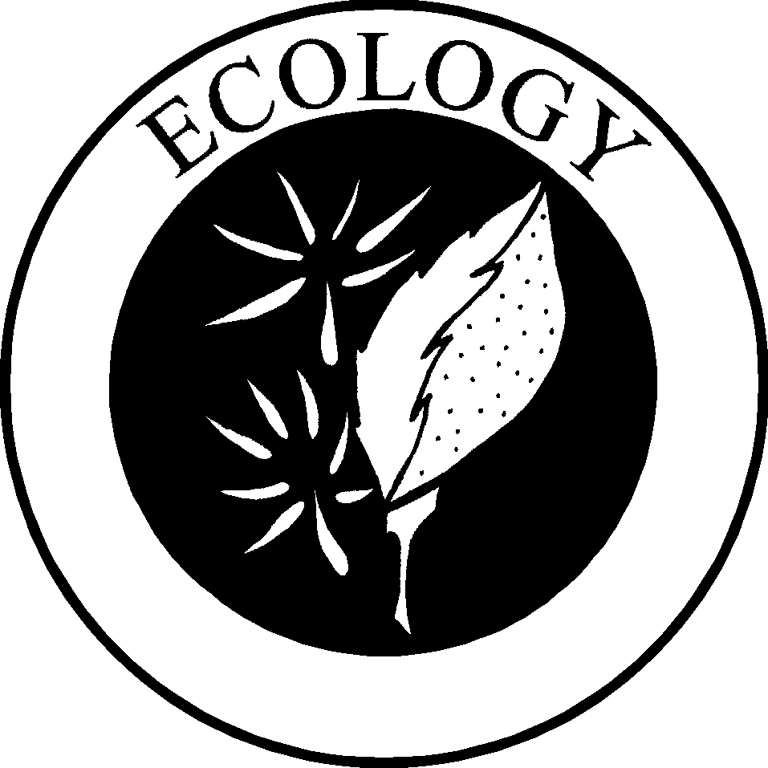

Bill Fontenot, SFO has served as Curator of Natural Sciences at the Acadiana Park Nature Center in Lafayette, LA for the past 18 years, and as nature columnist for the Lafayette Daily Advertiser since 1986. With wife Lydia, he also owns and operates Prairie Basse, a native plant nursery and ecological consulting business. Bill is a member of St. John the Evangelist Fraternity in Lafayette, LA, in Joan of Arc Regional Fraternity.

Ron Stoner, SFO is a consulting environmental risk manager in Rockville, MD. and a member of Saint Mary of the Angels fraternity, Margaret of Cortona Region.

Fred Young of Laurium, Michigan, lives on the shores of Lake Superior. Fred is a Doctoral Candidate in Environmental Studies at Michigan Tech University and studies wolves. He is a member of the St. Anthony of Padua Fraternity in the La Verna Regional Fraternity and was professed as a Secular Franciscan in 1983.

Fr. Larry Bernard, O.F.M. was ordained a Franciscan priest in June of 1966, and is currently pastor of both the Laguna and Acoma Catholic Indian Parishes. He is a member of the first class of New Mexico Stewards of Creation and is also Director of the Our Lady of Guadalupe Province office for Justice, Peace and Integrity of Creation. He presently creates an express bulletin eight times a year designed to motivate the reader to take specific actions to promote the well being of our life and world.

