NATIONAL FAMILY COMMISSION  MEMBERS | 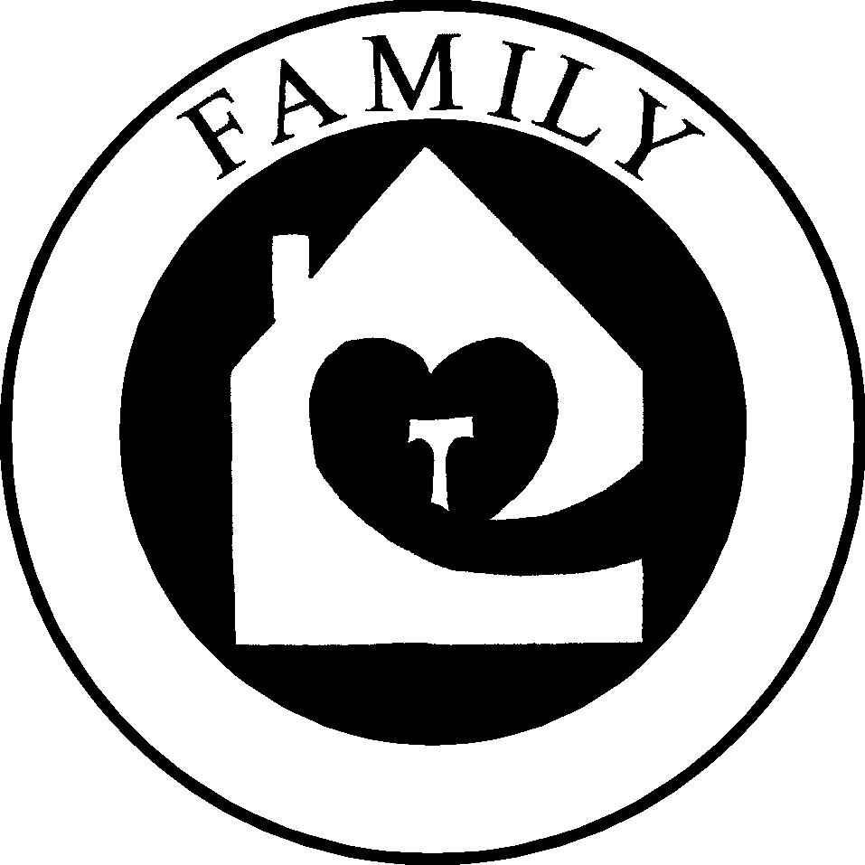

Jaime Bernardo and Sonia Bernardo, SFO serve as Co-chairs of the National Family Commission. They have been married for 43 years and are blessed with 3 sons and 4 grandchildren ages 11,10,4 and 2. Jaime was professed in 1985. An architect and interior designer by profession, he retired last October 2003 and at present enjoys his free time to create and design mostly religious art. Jaime is the Past Grand Knight of Blessed Manyanet Council of the Knights of Columbus in Silver Spring, MD. He was a member of the parish council at St. Catherine Laboure Church. Being Co-chair of the National Family Commission has drawn him closer to his purpose in life to serve God and to share his gifts with others. For Sonia, the joy of parenting has led her to advocate strongly for family unity which she believes is found in our relationship with God. Sonia retired in 1999 after working for 25 years at the University of Maryland; presently, she enjoys working as part time librarian for Franciscan friaries. Her Franciscan ministry includes: past Minister, Formation Director and Editor of her fraternity’s newsletter, The Angelus. Sonia publishes the Living by Faith, a monthly letter for the handicapped, the ill and the elderly.

Richard and RoAnne Fetkovich, SFO have married for 30 years. They have 5 children and blessed with 8 grandchildren. Both Rich and RoAnne recently retired from their jobs. Rich was a high school math teacher and guidance counselor. RoAnne worked as a nurse in a family physician’s office. They have been SFO members since 1983. They have held offices regionally and locally. For 6 years they have served as members of the National Family Commission.

Diane Halal, SFO has been a Secular Franciscan for almost fifty years and is a member of St. Maximilian Kolbe Fraternity in Francis Region. She has 7 children and 11 grandchildren, and is active in St. Hedwig Parish in Los Alamitos, Ca. She is a retired teacher, administrator and executive secretary. She is a past Provincial Minister and Regional Minister, and is in her second elected term as National Councilor, SFO. She has a long list of volunteer work amongst which is her work with Loaves and Fishes. She founded WE CARE (which served over 10,000 people last year). Currently she is Treasurer of Orange County Co and President of St. Vincent de Paul Society Conference. Diane was recently honored as Catholic Woman of the Year.

Jim Hein and Sis Hein, SFO have been married for 44 years. They have two children, two Golden Retrievers, one cat. Jim has worked in the hearing aid field for 20 years and Sis has worked as RN (Emergency Room) for 13 years and for 10 years as an OB - surgical nurse. They owned a family resort in Northern Minnesota for 23 years. For the past 15 years Franciscan Resources has been their apostolate. Jim is presently the Queen of Peace Regional Fraternity Minister and Sis serves as the Regional Family Commission Chair. Jim was editor of the St. Cloud Fraternity newsletter for 9 years and presently co-editor for the Regional newsletter "Tracings".

Alina Zygmunt, SFO is currently the Minister of the St. Mary of the Angels Fraternity in Rockville MD; she is the Family Commission Chairman for the Margaret of Cortona Region; and a member of the National Family Commission. She endeavors to implement the Franciscan values in all of the activities in which she is involved, from feeding the homeless to organizing a Commitment Mass. Alina’s family includes her husband Ted and two daughters, who support her lifestyle dedicated to helping others. Alina works full time at an Adult Medical Day Center.

William Wiethorn, OFM Cap serves as the Spiritual Assistant of the National
Family Commission. He is Vicar of the fraternity, which includes an assignment
for Asst. Formation at Capuchin College for Post- novitiate friars. He is the Local Director of the Capuchin Lay Volunteers. He is also Coordinator of the International Student Summer Program for Capuchins from other countries, who come here to the U.S. to study English. Presently, Fr. William serves as the Chaplain for Teams of Our Lady and is a regular Confessor at St. Luke's Institute. He was the English-Speaking Definitor General from 1994-2000 (Curia General O.F.M. Cap., Rome, Italy).

