NATIONAL FORMATION COMMISSION  MEMBERS | 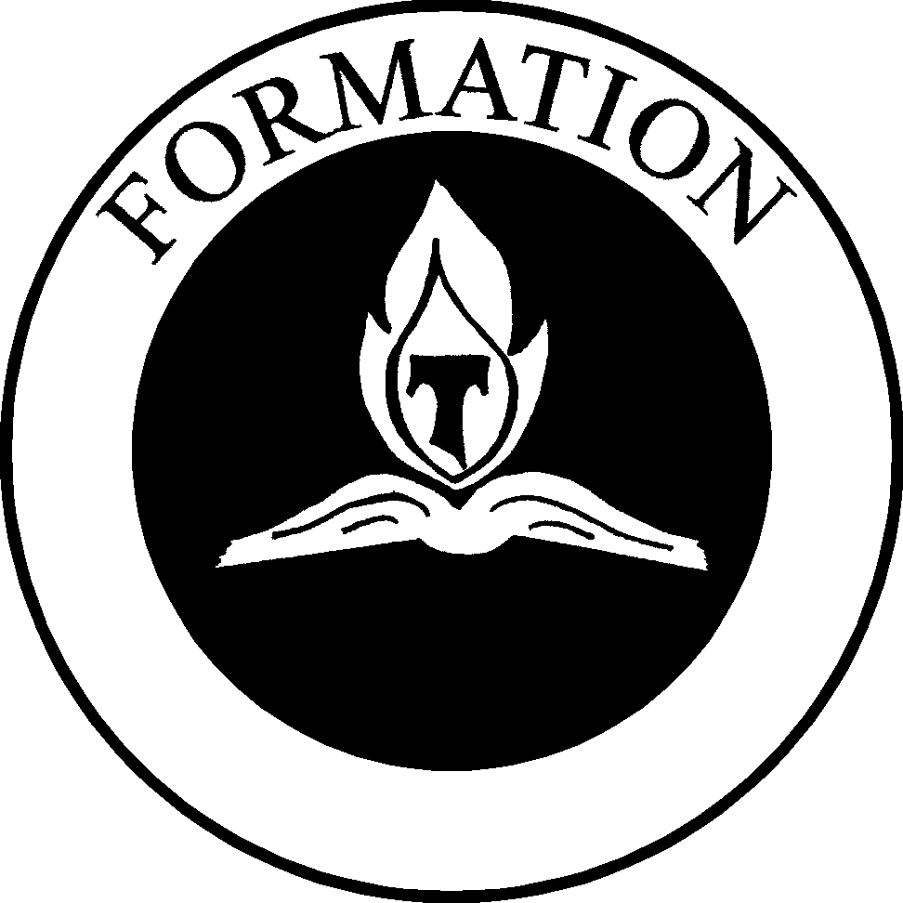

TERESA V. BAKER, SFO, Co-Chair of the National Formation Commission, is a member of the Greccio Fraternity in St. Elizabeth of Hungary Region. She resides in Derry, NH, with her husband, Raymond; they have two grown sons. In her parish, Teresa facilitates adult Scripture Sharing and Faith formation. Teresa has served as Formation Director on all levels of fraternity. She has authored Gospel Living Every Day of Our Lives: A Formation Guide to the Rule of the Secular Franciscan Order, an outgrowth of her master’s thesis at Boston College. She has also co-authored Come and See with Fr. Lester Bach, OFM Cap. She travels around the country giving workshops and retreats.

ANNE H. MULQUEEN, SFO, Co-Chair of the National Formation Commission, is a member of Mary Our Queen Fraternity in Saint Margaret of Cortona Region. Anne was professed in 1984. She resides in Kingsville, MD, with her husband, Bill. They have two daughters and two grandchildren. Anne chairs the Evangelization Committee in her parish and teaches scripture study. She is trained as a Spiritual Director and continues to serve in that capacity. She is a Reader/Instructor for the Institute for Contemporary Franciscan Life. She has served as Formation Director on the local, provincial, regional, and national levels of fraternity.

CLAIRE BREEN, SFO, appointed to the National Formation Commission in 2003, is a member of St. John’s Fraternity in Junipero Serra Region. Professed in 1987, she has served the Fraternity as Secretary, Vice Minister, Minister and member of the Formation Team for many years. In 1997, was appointed as the Commission Coordinator for the Junipero Serra Region. In 2000, Claire was elected as Regional Formation Director and has continued to serve in this capacity. She also serves St. Joseph’s Fraternity, Bakersfield, CA as their Spiritual Assistant.

CARLOS CALDERON, SFO, appointed to the National Formation Commission in 2003, is a member of the St. Maximilian Fraternity in Deltona Florida in Five Franciscan Martyrs Region. Carlos and his wife have four children, 11 grand children and 1 great grandson. Carlos holds a Master’s of Science Degree and is a Certified Addiction Professional in Florida. He has held several positions on the local fraternity council and has served as regional Formation Director. Presently, Carlos serves as Minister of Five Franciscan Martyrs Regional Fraternity.

DEACON OSCAR PEREZ, SFO, appointed to the National Formation Commission in 2003, is a member of St. Anthony Fraternity in Los Tres Companeros Regional Fraternity. He is married to Elena and they have two grown children, Christine and Carlos. Oscar was professed in 1988 and ordained in 1990 as a deacon for the Diocese of Brownsville. Oscar has served the Order in many capacities: local minister, regional vice minister and minister for Los Tres Companeros. He has served as Youth/Young Adult Regional Chair and on the National Youth/Young Adult Commission. Oscar recently completed his term as Councilor on the National Executive Council.

FR. RICHARD TREZZA, OFM, is a friar of Holy Name Province, New York. He currently serves as Provincial Spiritual Assistant for the SFO for his province and Parochial Vicar at Holy Name Parish in New York City. He has ministered to the SFO since 1968, and is presently the Spiritual Assistant for the National Commission chairs and also Spiritual Assistant to the National Formation Commission. His SFO ministry also extends to that of Regional Spiritual Assistant to Our Lady of the Angels Region. He is also a chaplain for the Genesis Program, a middle school for gifted children sponsored by the Diocese of Brooklyn, NY. Father joined the Franciscans in 1966. He has graduate degrees in Music, Education, and Theology.

