NATIONAL PEACE AND JUSTICE COMMISSION  MEMBERS | 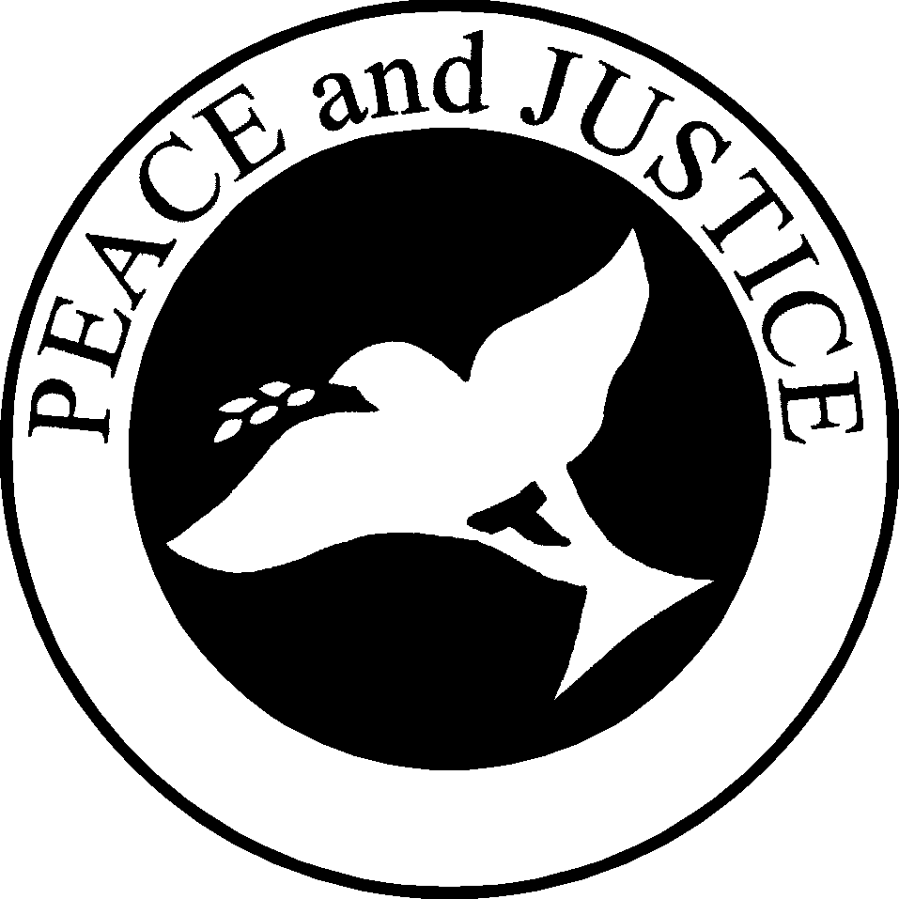

Carolyn Colburn, SFO serves as the Chair of the Peace and Justice Commission. She was professed in 1991 and is presently a member of Our Lady of Angels Fraternity in Burlingame, California, in Blessed Junipero Serra Region. Carolyn has a B.A. degree in Psychology and a M.A. degree in Education from the University of California, Berkeley. Her interest in social justice began as a child growing up in a family with a strong commitment to organized labor. As a teacher, she was active in the California Teachers’ Association, working for better wages and working conditions for teachers. Carolyn has served as Commissioner for Peace and Justice for Blessed Junipero Serra Regional Fraternity. Carolyn works in prison ministry at the San Mateo County Juvenile Detention Facility. Carolyn lives in Foster City, California. She is married and has a daughter.

Theresa Egan, SFO was professed in at St. Mary of the Angels Fraternity in Rockville, Maryland in 1999. Presently, she belongs to Mary Our Queen Fraternity in Baltimore in St. Margaret of Cortona Regional Fraternity. She is the Peace and Justice Commissioner for her region and for her fraternity. Theresa has a B.A. degree in romance languages from the University of Michigan and an M.S. in Library Science from the University of Southern California. She is retired from the Department of Energy. Theresa’s sense of justice was formed when she was a child and was directed toward the Native Americans. She has volunteered as a mentor at a school on the Hopi Reservation. She has worked with Native Americans at the Missionaries of Charity homeless shelter in Gallup, New Mexico. She is very involved with the Holy Land Christian Ecumenical Foundation, an organization that helps Palestinian Christians. Theresa has been married and has two grown daughters and five grandchildren. She lives in Towson, Maryland.

Jo-Ann Hardwick and Ray Hardwick, SFO were professed in 1963. They are members of Immaculata Fraternity in Riverside, California in St. Francis Regional Fraternity. They have been involved in peace and justice advocacy and education for 25 years. At the Regional level, Jo-Ann and Ray have given talks to fraternities and regional gatherings on Catholic social teaching, Franciscan peacemaking, and Christian/Franciscan Non-Violence. Both Ray and Jo-Anne have been involved in peace rallies and demonstrations at Vandenberg Air Force Base and in rallies and demonstrations against the death penalty. Jo-Ann sees her ministry as that of a prayer warrior who brings to her work wisdom honed through many years of prayer and suffering for the Body of Christ. Ray has written a musical play, “The Servant,” that was produced and performed in 1982 and 198. He has written an article, “Who Are Secular Franciscans?” for the national magazine Prayer and Vocations. Jo-Ann and Ray have been married for 50 years. They have three children, seven grandchildren and eight great grandchildren. They live in Corona, California.

Patricia Mulligan, SFO was professed at Holy Spirit Fraternity in Sharon, Pennsylvania, in 1994. She has served the Order as Fraternity Minister, Fraternity Peace and Justice Commissioner and is the Regional Peace and Justice Commissioner for our Lady of Poverty Regional Fraternity. Before retiring, she was a Regional Director of Marketing for Pennsylvania’s largest shopping mall developer. Patricia was a member of the Erie Diocesan Natural Family Planning Board and is a volunteer at the Catholic Charities Prince of Peace Center. She has been an instructor in several Scripture studies and has facilitated retreats for prison inmates. She initiated a yearly Franciscan Peace Award in four diocesan Catholic schools. In 1999, she received the Erie Diocesan Catholic Charities Caritas Award. Patricia is a widow. She has twenty grandchildren, four great grandchildren and provided a home for five foster children. She lives in Sharon, Pennsylvania, ninety miles south of Lake Erie.

Father David A. Moczulski, OFM serves as the Spiritual Assistant for the Peace and Justice Commission. He is a friar of the Province of Saint John the Baptist. Professed on August 2, 1989, he was on ordained May 29, 1993. Fr. David received his Master of Divinity degree from Washington Theological Union and a Master of Arts in Spirituality and Franciscan Studies from the Washington Theological Union in 1993. He served as Provincial Coordinator of Justice, Peace and Integrity of Creation, and chaired the English-Speaking Conference (OFM), Justice, Peace and Integrity of Creation Council. He has been the Director of the Franciscan Washington Office for Latin America, and is former member of the Board of Directors of Franciscans International. Presently, he serves as Chaplain for the Sisters of the Holy Family of Nazareth, assists in parishes, and facilitates retreats and Parish Missions.

