NATIONAL WORK COMMISSION  MEMBERS | 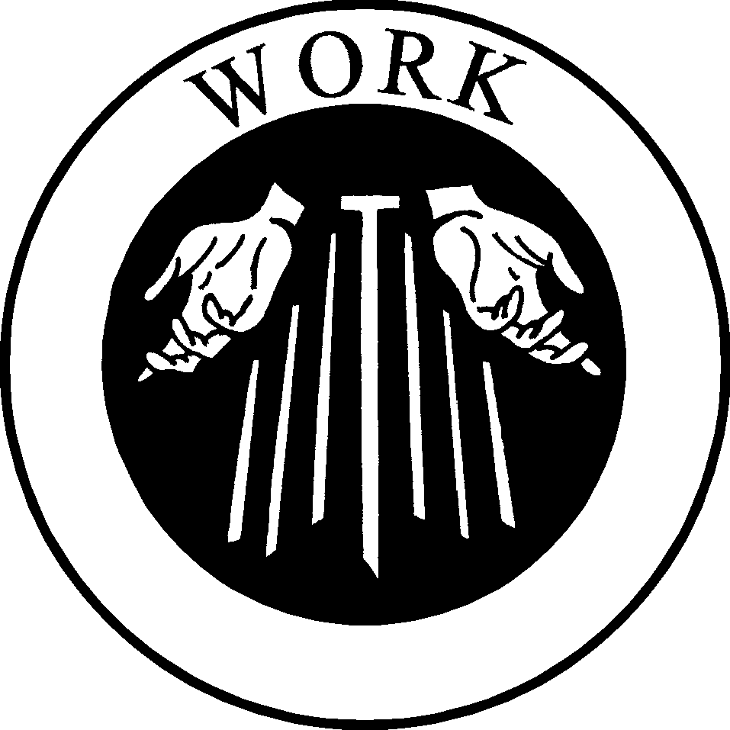

Pauline Cahalan, SFO, serves as NAFRA Work Commission Chair. Pauline was professed in Nov. 1987 in Woodruff, WI. She retired from a 34 year career as an RN and now teachers English as a Second Language to adult immigrants in St. Paul, MN. She has held various positions with fraternal councils, helped
organize the Los Tres Companeros Regional Fraternity, was Regional Work Commission Chair and is in her second 3 year term.

Mary Young Kim, SFO is a member of the Korean Martyrs Fraternity of New York. She was professed on November 4, 2001. Mary was active in the translation of two Franciscan works into Korean: Catch Me a Rainbow Too and Franciscan Gospel Life in the Contemporary World. Mary offers financial assistance to "Franciscan House" in New York. Mary attended the 16th Quinquennial Congress in Loyola Univ., in New Orleans, LA July, 2002.

Sally Haddad, SFO, was professed at St. Pius X Fraternity in 1985. She has
served her local fraternity in various positions both on & off the council,
served the Fr. Solanus Casey Regional Fraternity as Work Commission Chair since 1998, and has also been a member of the NAFRA Work Commission since 2001. Sally developed and presented different workshops regarding Franciscan Spirituality and work. She has written articles about work related issues for her regional newsletter and for the TAU-USA. At her pastor's request, she wrote prayers for each Station of the Cross for those monetarily unemployed. She has worked at Electric Boat in Groton, CT for 30 years, is married to Chuck (also an SFO), and likes to sew and crochet.

Teresa S. Redder, SFO, belongs to Holy Assumption Fraternity located in
Roebling, NJ in St. Katharine Drexel Regional Fraternity, where she was professed in 1992. A logistics program manager for Lockheed Martin, she also served as a logistics commander in the U.S. Air Force Reserve, retiring after 23 years service. Since returning from an overseas assignment in 1983, Teresa has lived in Eastampton, NJ, with her Secular Franciscan husband Jeff and their four children (Ann, Nadia, Mike, and Matt). In June, they welcomed their first granddaughter, Madyson May. In her parish/diocesan ministry, Teresa facilitates a weekly faith-sharing group at the local men's prison.

Maria S. Batista, SFO works as a 2nd grade bilingual teacher. She has two
daughters, one son, and one grandson. She belongs to the fraternity "San Luis
Rey" at Our Lady of Guadalupe in El Paso, TX. She is a Secular Franciscan of
34 years. She has served as local minister of her fraternity for 6 years.
Currently, she works with the Regional Council as an Area Representative for the fraternities in El Paso.

