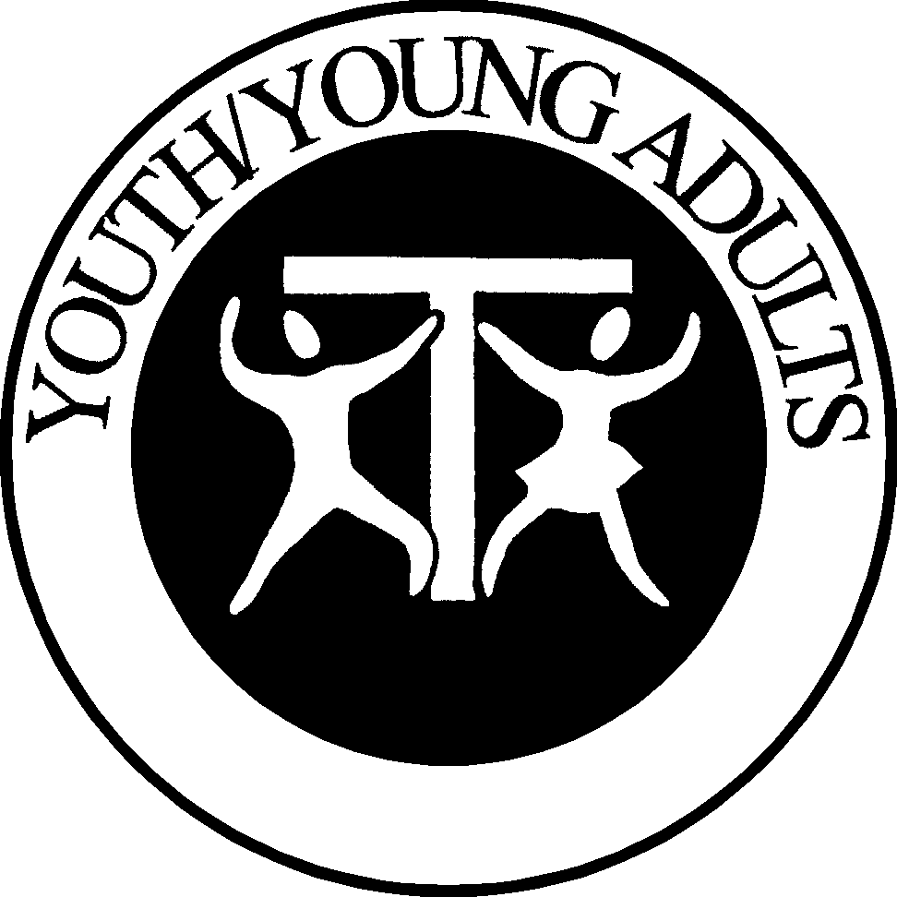

Youth/Young Adult Commissions
Biographies and Terms

Kathy Taormina, SFO – is married, has 4 children and has been working with parish youth for 25 years and Franciscan Youth for 10 years. Since 1996 she has served on the SFO National Youth/Young Adult Commission, and in October 2002 she became its Chairperson. She is currently involved in reestablishing a fraternity in the Twin Cities area that will have a Youth/Young Adult focus. She has attended 3 Franciscan World Youth Day Delegate Celebrations and is currently working towards World Youth Day 2005 in Cologne, Germany. Professed in 1994, she has also been a local Minister and Formation Director and Lady Poverty Regional Youth/Young Adult Commission Chair. On November 1, 2003 she was elected as a National Fraternity Councilor for a three-year term.
1996-1999 – member (first term) 920 Whitney Drive
1999-2002 – member (second term) Apple Valley, MN 55124
2002-2005 – chair (first term) 952.997.2243
2003-2006 – National Fraternity Councilor kltsfo@frontiernet.net

Jeanie McLees, SFO – is the Regional Youth/Young Adult Commission Chair for St. Margaret of Cortona Region. She was professed in 1989, and has been a local Minister and is currently Formation Director for Sacred Heart Fraternity, VA Beach. At the local campus ODU University she encourages fraternity members to make a meal to share and take it to the campus so that the students can enjoy a home cooked meal and also share fellowship, this is usually done during the holiday season. She visits local jails to provide religious items, and enjoys knitting baby hats for the newborns at a local hospital. She was appointed to the Youth/Young Adult Commission in 2000 and has just begun her second three-year term.
2000-2003 – member (first term) 808 Angela Court
2003-2006 – member (second term) Virginia Beach, VA 23455
757.557.0107
scottish.wench@cox.net

Vivian F. Weaver, SFO - is married, has two adult children and has a Bachelor of Arts in Social Studies and Secondary Education (7-12) from Geneva College. She taught 5-8th grade Catholic School including 5-6th grade Religion for 6 years, CCD for seven years and Youth Group for one year. She is employed by her husband’s architect business. She was professed in 1983 and is the co-founder of Bl. John Duns Scotus newly forming group. She has also held the position of Regional Secretary and Newsletter Editor for Lady Poverty Region and worked with Fr. Bernie Tickerhoof, TOR’s doctorial project on developing leadership in the SFO. She was appointed to the Youth/Young adult Commission in 2002.
2002-2005 – member (first term) 255 Mercer Street
Harmony, PA 16037
724.712.0584
vfwsfo@zbzoom.net

Brother James Boyle, TOR - was professed as a friar in 1967 and has served in education on the secondary and college level as administrator and teacher. Brother Jim has served as a Spiritual Assistant on the Local, Regional and National level. He is currently the Pastoral Administrator of the Kartause Church in Gaming, Austria. Br. Jim was appointed as Spiritual Assistant to the Youth/Young Adult Commission in 2002.
2003-2006 – Spiritual Assistant Holy Spirit Friary
1235 University Blvd.
Steubenville, OH 43952
boyleja@juno.com

