A GUIDE FOR FRANCISCAN
YOUTH/YOUNG ADULT MINISTRY

THE NATIONAL FRATERNITY
OF THE
SECULAR FRANCISCAN ORDER---USA

Prepared by
The National Secular Franciscan
Youth/Young Adult Commission

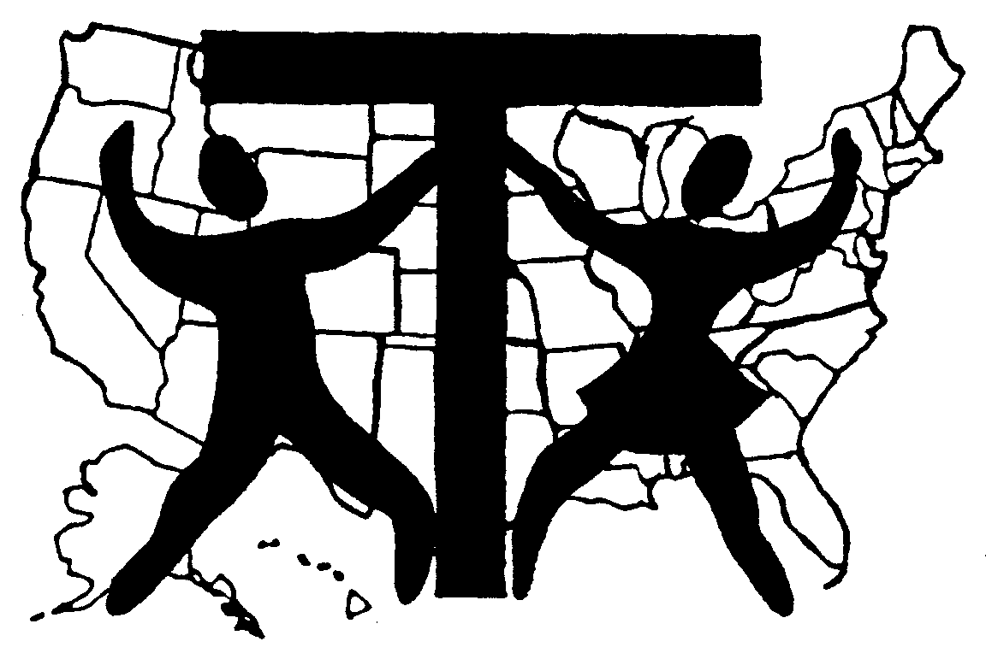

2004 Revised Edition

TO ORDER THIS GUIDE:

Order From:
Barbo-Carlson Enterprises, Box 189, Lindsborg, KS 67456
Phone 785.227.2364, Fax 785.227.3360,
Email bevbarbo@informatics.net
#108 1-9 copies…..$10.00 ea. +S/H
#108 10 or more..….$8.00 ea. +S/H

