NEWS
NATIONAL FRATERNITY
SECULAR FRANCISCAN ORDER
IN THE UNITED STATES

Media Contact:
Bob Stronach, OFS, 315-796-9468; Mary Stronach, OFS, 315-796-9284, stronach@kateriregion.org

FOR IMMEDIATE RELEASE: Oct. 18, 2012

Advocate Receives 'Justice, Peace & Integrity of Creation Award'
JANICE BENTON HEADS NATIONAL CATHOLIC PARTNERSHIP ON DISABILITY
DENVER -- "Don't think of disabilities as exceptional…We say it's a normal part of life."

That's how Janice L. Benton, OFS, described her advocacy work Oct. 18 before the national gathering of the U.S. Secular Franciscan Order in Denver, Colorado -- where she was honored with the Franciscan Justice, Peace and Integrity of Creation (JPIC) Award.

"You should make assumptions that people with disabilities want to be part of our community."
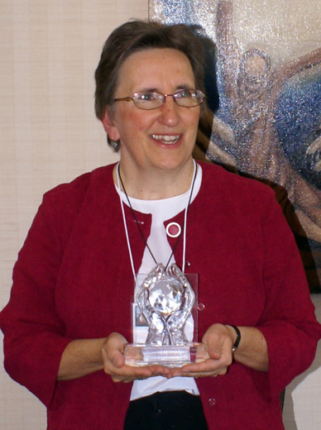
A Secular Franciscan herself, Benton encouraged the 80 chapter attendees, representing over 13,000 Secular Franciscans across the U.S. and Guam, to start building relationships, one on one. The Franciscan vocation, she noted, is about affirming the dignity of life, and that covers a wide range of people -- those with such disorders as Down syndrome, refugees who come across the border, victims of human trafficking, elderly persons deteriorating physically and mentally, homeless children everywhere.

Recognizing the needs of people with disabilities is not just an issue of charity, Benton said. "You're not doing anyone any favor if you sentimentalize people with disabilities and their care givers…It's an issue of justice."

Justice, first of all, means recognizing people as having value, she said, and fighting against such things as abuse in institutions and providing what people need to be able to participate meaningfully in life.

A big concern for her, she said, is that "our society, our culture is teaching that some people are disposable." These folks are "despised" because they're costly, inconvenient or requiring too much time. This involves everything from aborting less-than-perfect babies to organ donation pressure to so-called compassionate death.

That's where Franciscans come in, she said, because they understand, as Franciscan Theologian Sr. Ilia Delio put it at the Secular Franciscan Quinquennial Congress in July, that all of humanity is imprinted with the dignity of God and that nothing in creation is accidental and nothing is worthless.

Benton has been an advocate for 30 years, including the last eight as executive director of the National Catholic Partnership on Disability (NCPD) in Washington, D.C. She resides in College Park, Maryland, with her husband, Martin, and worships at St. Camillus Parish in Silver Spring, Maryland. Knowledgeable in sign language, she serves as vocation director for a fraternity of deaf Secular Franciscans. Earlier this year she received the Harry A. Fagan Award from the National Association of Catholic Diocesan Social Justice Directors.

National Minister Deacon Tom Bello, OFS, presented the JPIC Award, a glass statue of a pair of hands enveloping the globe, along with a $2,000 prize, noting: "You are a hero for me. You are my 'Secular Franciscan' Secular Franciscan."

Formerly known as the Peace Award, it was renamed to capture the significant inter-related efforts in the areas of justice, peace and the integrity of creation, noted JPIC Chairman Kent Ferris, OFS. "Our Franciscan Rule reminds us of our responsibility to 'individually and collectively be in the forefront of promoting justice by the testimony of our lives.' The JPIC Award allows us to recognize those who have modeled such courageous efforts."

The annual award was revived in 2007 after a lapse of several years. The 2007 award recognized the work of Dr. Tony Lazzara, an American physician and Secular Franciscan who operates a clinic and shelter for ailing children in Peru. The 2008 award honored Marie Dennis, a Secular Franciscan who directs the Maryknoll Office for Global Concerns and who is immersed in advocating on behalf of people marginalized by society, poverty, abuse, war, violence, and human trafficking. The 2009 award went to Don Ryder, a Secular Franciscan from Wisconsin who helped save the Maasai people in Kenya from disease and drought by drilling water wells. In 2010 it honored Br. David Bauer, OFM, for his work with the homeless and marginalized in Tuscon and Las Vegas. Last year the award went to Fr. Louie Vitale, OFM, a Franciscan friar known for protests against war and torture and advocacy for the poor.

Among the more notable prior recipients were the Rev. Dr. Martin Luther King Jr. and Mother Teresa of Calcutta.

The Secular Franciscan Order is an order of single and married Catholics who profess to bring the Gospel to life in the spirit of St. Francis.

###

