NEWS
NATIONAL FRATERNITY
SECULAR FRANCISCAN ORDER
IN THE UNITED STATES

Media Contact:
Bob Stronach, OFS, 315-796-9468; Mary Stronach, OFS, 315-796-9284, stronach@kateriregion.org

FOR IMMEDIATE RELEASE: Oct. 19, 2013

Physician Receives 'Justice, Peace & Integrity of Creation Award'
FOUNDED MINISTRY TO HELP ALLEVIATE POVERTY IN DEVELOPING COUNTRIES

KANSAS CITY, KS -- A visit to East Africa in 2001 changed Dr. Margie Sweeney's life. The poverty she saw, and the realization, she said, that God was calling her, led the family physician to found the nonprofit charity, Helping Hands Healing Ministries, Inc. (HHHM) to help alleviate poverty in developing countries.

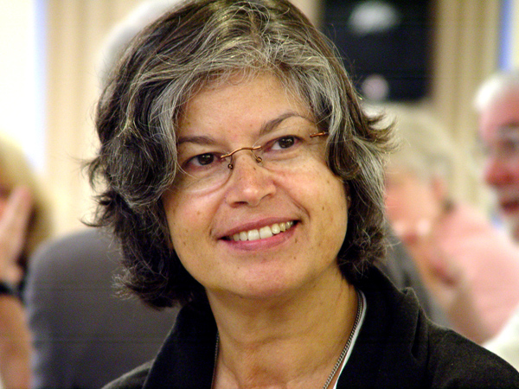
For her efforts and example, Dr. Sweeney received the Franciscan Justice, Peace and Integrity of Creation (JPIC) Award during the annual chapter of the Secular Franciscan Order in the United States, held Oct. 16-20 at Savior Pastoral Center in Kansas City.

National Minister Deacon Tom Bello, OFS, presented the JPIC Award, a glass statue of a pair of hands enveloping the globe, along with a $2,000 prize. JPIC Chair Kent Ferris, OFS, cited several of her projects, such as assisting a school in Zambia with electrical hook-ups, starting a dairy farm in Tanzania to provide nutrition to 400 people, offering tuition assistance for various students in Africa, and more recently, making a series of medical mission trips to Haiti.

A professed Secular Franciscan herself, Dr. Sweeney is minister of St. Michael the Archangel Fraternity in Tampa, FL. She resides in St. Cloud, FL with her civil-engineer husband, Michael. They have a son, Patrick, and a daughter, Kelly.

Her trip to Africa was memorable for another reason. She landed at Nairobi, Kenya on Sept. 11, 2001. She didn't know about the terrorist attacks back in America until a nun came up to her at the airport and said she was so sorry.

"I gained a new level of faith and trust in God," she told the 80 chapter attendees, representing over 13,000 Secular Franciscans across the U.S. and Guam. "I had a new attitude of gratitude."

Formerly known as the Peace Award, it was renamed to capture the significant inter-related efforts in the areas of justice, peace and the integrity of creation, noted Ferris, OFS. "Our Franciscan Rule reminds us of our responsibility to 'individually and collectively be in the forefront of promoting justice by the testimony of our lives.' The JPIC Award allows us to recognize those who have modeled such courageous efforts."

The annual award was revived in 2007 after a lapse of several years. The 2007 award recognized the work of Dr. Tony Lazzara, an American physician and Secular Franciscan who operates a clinic and shelter for ailing children in Peru. The 2008 award honored Marie Dennis, a Secular Franciscan who directs the Maryknoll Office for Global Concerns and who is immersed in advocating on behalf of people marginalized by society, poverty, abuse, war, violence, and human trafficking. The 2009 award went to Don Ryder, a Secular Franciscan from Wisconsin who helped save the Maasai people in Kenya from disease and drought by drilling water wells. In 2010 it honored Br. David Buer, OFM, for his work with the homeless and marginalized in Tuscon and Las Vegas. In 2011 the award went to Fr. Louie Vitale, OFM, a Franciscan friar known for protests against war and torture and advocacy for the poor. Last year Janice Benton, a Secular Franciscan from Maryland, was honored for her advocacy work for people with disabilities.

Among the more notable prior recipients were the Rev. Dr. Martin Luther King Jr. and Mother Teresa of Calcutta.

The Secular Franciscan Order is an order of single and married Catholics who profess to bring the Gospel to life in the spirit of St. Francis.

###

