NEWS
NATIONAL FRATERNITY
SECULAR FRANCISCAN ORDER
OF THE UNITED STATES

CONTACT: Bob Stronach, OFS, stronach@kateriregion.org, 315-796-9468,
or Mary Stronach, OFS, stronach@kateriregion.org, 315-796-9284

FOR IMMEDIATE RELEASE: Oct. 25, 2014

Tucson Bishop Receives Franciscan Justice/Peace Award

DALLAS – Citing his “ground zero” work on behalf of desperate migrants in southern Arizona, the Secular Franciscan Order is honoring Tucson Bishop Gerald F. Kicanas, D.D., with the Franciscan Justice, Peace and Integrity of Creation (JPIC) Award.

The award was announced at the Order's national annual gathering, held Oct. 21-26 at Montserrat Jesuit Retreat House, Lake Dallas, Texas.

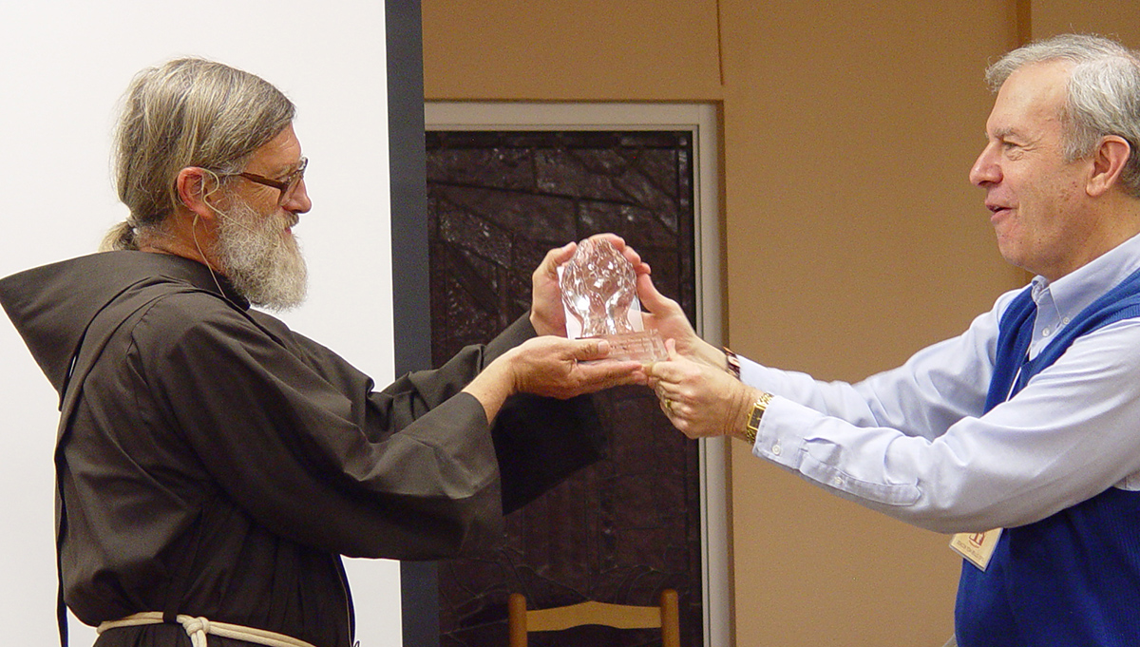
Br. David Buer, OFM, a Franciscan friar who himself received the JPIC Award in 2010 for his work with the homeless and migrants in Arizona, accepted the award on behalf of Bishop Kicanas, who was unable to be present.

JPIC Commission Chair Carolyn Townes, OFS, introduced Brother David and National Minister Deacon Tom Bello, OFS, presented the award, saying the bishop “exemplifies the Franciscan values of peacemaking, charity and justice for the poor.” The award included a glass statue of “God's hands embracing the world,” and a $2,000 prize.

In a video message, Bishop Kicanas expressed “deep gratitude,” praised the advocacy of Secular Franciscans on behalf of the poor and homeless, and said the award encourages him and others to continue the fight to fix a broken immigration system.

Secular Franciscans nominating the bishop wrote: “Over the last decade, southern Arizona has been ‘ground zero’ for the humanitarian crisis of desperate migrants risking their lives, by crossing the desert on foot. Each year, 150-200 human remains are found in the desert around Tucson. Many more hundreds are found each year along the Mexican border in Texas, New Mexico and California.

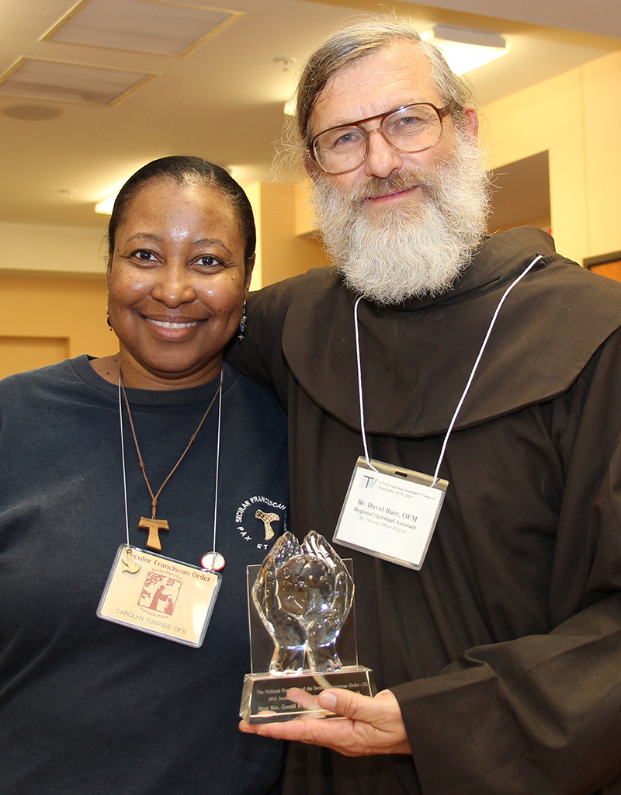
“Bishop Kicanas has been tirelessly working to create bridges of love and concern in an era of wall building and militarization. He helped form the 'Dioceses Without Borders' project, which unites the Catholic Dioceses of Phoenix, Tucson and Hermosillo, Sonora, Mexico, to work together on migration issues. He reaches out to all the human beings in the borderlands: the humanitarian groups; the Border Patrol and other enforcement agencies; the migrants; the faith community; the ranchers and elected officials. He welcomed the Jesuit's Kino Border Initiative project in Nogales. Bishop Kicanas' commitment has also played an important role nationally, testifying before Congress, for the need for comprehensive immigration reform.”

The annual award, formerly known as the Franciscan Peace Award, was revived in 2007 after a lapse of several years. The 2007 award recognized the work of Dr. Tony Lazzara, an American physician and Secular Franciscan who operates a clinic and shelter for ailing children in Peru. The 2008 award honored Marie Dennis, a Secular Franciscan who directs the Maryknoll Office for Global Concerns and who is immersed in advocating on behalf of people marginalized by society, poverty, abuse, war, violence, and human trafficking. The 2009 award went to Don Ryder, a Secular Franciscan from Wisconsin who helped save the Maasai people in Kenya from disease and drought by drilling water wells. In 2010 it honored Br. David Buer, OFM, for his work with the homeless and marginalized in Tuscon and Las Vegas. In 2011 the award went to Fr. Louie Vitale, OFM, a Franciscan friar known for protests against war and torture and advocacy for the poor. In 2012 Janice Benton, a Secular Franciscan from Maryland, was honored for her advocacy work for people with disabilities. Last year Florida physician Dr. Margie Sweeney, a Secular Franciscan, was honored for her work toward alleviating poverty in developing countries.

Among the more notable prior recipients were the Rev. Dr. Martin Luther King Jr. and Mother Teresa of Calcutta.

The Secular Franciscan Order is an order of single and married Catholics who profess to bring the Gospel to life in the spirit of St. Francis of Assisi.

###

PHOTOS:
1. Franciscan Brother David Buer, OFM, accepts the Franciscan Peace & Justice Award on behalf of Tuscon Bishop Gerald F. Kicanas from Deacon Tom Bello, OFS, national minister of the Secular Franciscan Order. The award was presented during a national Secular Franciscan gathering in Dallas.
2. Carolyn Townes, OFS, and Br. David Buer, OFM, pose with the Franciscan Peace and Justice Award that was awarded to Tucson Bishop Gerald Kicanas. Townes chairs the Justice, Peace and Integrity of Creation Commission that oversees the award and Brother David accepted the award on behalf of the bishop.
###

