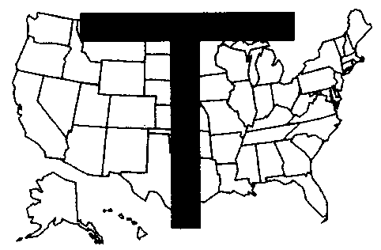
THE NATIONAL FRATERNITY OF
THE SECULAR FRANCISCAN ORDER – USA

Multicultural Committee

Sonia Bernardo,SFO
Chairman
11704 Veirs Mill Rd.
Silver Spring, MD 20902
301-933-2487
Email: Jsbernardo@msn.com

ANNUAL REPORT To NAFRA Council July 2004 - Oct.2004

Appointment : Chairman of the Multicultural Committee effective July 1, 2004.

Members : Peter Nguyen Duc Hanh - Vietnamese Formation materials; Adelina Frisbie - Spanish Formation materials; Rosa Youm Sun Ock - Korean Formation materials; and Barbara Smith and Roberto Vela.

Projects : Recruit a few more members who will represent other ethnic cultures; Set up meetings with all members to discuss the Committee’s mission, goals and objectives; Organize workshops and invite resource persons who are experts in multiculturalism.

VI LatinoAmericano Congreso OSF-JUFRA – Our National Minister, Carol Gentile delegated me to the 6th Congress of the Latin-American SFO-Jufra in Mexico City last Sept 14 – 19, 2004 for NAFRA. About 95 delegates composed of National Ministers, Regional Ministers, Youth Coordinators and Spiritual Assistants from Latin American countries were in attendance. National Minister Samuel Murguia, OSF, National Asst. Minister, Friar Arturo Bustamante, OFM, and National Secretary Grimaldi, OSF of the host country, organized and coordinated the
successful event with the help of JUFRA headed by the National Coordinator of Franciscan and the Latin American Youth Groups, Juan Roberto Figueroa Garcia, Jufra.

Minister General, Encarnacion del Pozo, OSF of Spain gave the opening remarks affirming the spirit and objective of the VI Congreso Latinoamericano OFS-JUFRA. The Apostolic Nuncio to Mexico, His Eminence Guiseppe Bertello and special guest from Rome, Fr. Ivan Matic, OFM, General Spiritual Asst of the SFO and Franciscan Youth Group were among the Eucharist celebrants. I read our Minister Carol Gentile’s Message to the Congress in Spanish which was well-received with loud and prolonged applause.

The general sessions, topical breakout sessions, small group meetings reflected on the different themes presented.
The most important aspect of the Congress was having the opinions of the different countries regarding the themes be heard. The themes were: Theme 1 “Living together as a Family – Relationships between SFO and Franciscan Youth Groups, Relationships in the Franciscan Family and Relationship with the Youth Movements in the Church”; Theme 2 “Promotion of Fraternal Relations on the International Level” (which I participated in); Theme 3 “The OSF in the Local Church”; Theme 4 “Relationship and Presence of the SFO and Franciscan Youth Groups in the Various Ethnic Groups of Latin America”; and Theme 5 “Relationship of the SFO and Franciscan Youth Groups with other Christian Communities”.

The theme of the Congress was “Haznos Senor, instrumentos de tu Paz” (Lord, Make Me An Instrument of Your
Peace). I received a specially made stole with the embroidered image of Our Lady of Guadalupe and the “XL VIII Congreso Eucaristico Internacional” on behalf of our National Minister.

It was such a rewarding and wonderful experience to meet and be with our Franciscan brothers and sisters from the Latin American countries of Mexico, Bolivia, Peru, Colombia, El Salvador, Guatemala, Brazil, Venezuela, Puerto Rico, Panama, Ecuador, Dominican Republic, Nicaragua, Santo Domingo and to learn their cultures, customs and traditions. Although I know very little Spanish and most of them do not speak English, we were able
to communicate through our hearts. An interpreter who was assigned to me throughout the Congress was very helpful. Each country has its own richness and uniqueness. Working together in which multiple cultures exist peaceably side by side is such a gift and a true witness to the presence of the Franciscan spirit. We celebrated our diversity as well as our commonality. In many ways we are all joined by one faith and it shows how it takes all cultures and languages to lift up the overwhelming richness of God’s gift and creativity.

On the third day of the Congress we and thousands of Secular Franciscans throughout Mexico made a pilgrimage
to the imposing Basilica of the Shrine of Our Lady of Guadalupe.

As the new chairman of the National Multicultural Committee, it was a great opportunity and a humbling experience to witness the simplicity and dignity of our brothers and sisters in that part of the world. I was overwhelmed by the warmth and love that emanated from their hearts. I was awed by the thoughts and ideas which came from their unique ethnic backgrounds and life experiences. It is a gift that I will cherish and share with everyone.

Submitted by:
Sonia Bernardo, SFO, Chairman

