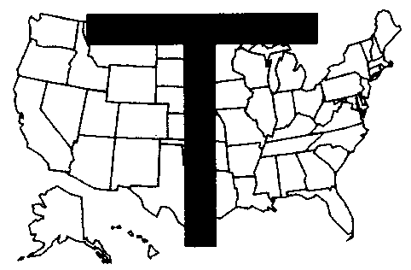
THE NATIONAL FRATERNITY OF
THE SECULAR FRANCISCAN ORDER – USA

FAMILY COMMISSION
Jaime & Sonia Bernardo,SFO Richard & RoAnne Fetkovich, SFO
(Chairs through June 2004) (Acting Chairs July 2004)
11704 Veirs Mill Rd. 1067 Timberwood Dr
Silver Spring, MD 20902 Beaver Falls, PA 15010
301-933-2487 724-843-8668
Email: Jsbernardo@msn.com Email: fetsfo@yahoo.com

Annual Report to NAFRA Council, Oct 2003-Oct 2004
Activities of the National Family Commission

Meetings and presentations:
- Nov.15-17, 2003 – The Bernardo’s presented the Family of the Year Award 2003 to Marion and Maurice Umbdenstock, SFO, Mother Cabrini Region in Chicago IL. It was held on the feast day of Mother Cabrini.
- January 2004 – The Bernardo’s gave a talk on how to start a family commission at the fraternity meeting of Elizabeth Ann Seton Fraternity in Emmitsburg, MD
- March 19-21, 2004 – Committee members held a meeting in Aliquippa, PA at the residence of Rich and RoAnne Fetkovich to finalize plans for the Family Commission sessions at the ACC June 2004.
- March 27- April 6, 2004 – The Bernardo’s journeyed with all the other Commission Chairs led by our Spiritual Asst. Fr. Richard Trezza to Assisi, Italy to get first hand experience and knowledge of the significant places in Francis’ life – his home and the place where he grew up, where his family lived, the streets that he roamed, the caves that he went to in order to meditate and communicate with God, the place where he received his stigmata,etc.
- June 17-20, 2004 – The Family Commission attended the ACC held in Denver Colorado. The Bernardo’s visit to Assisi made prepared them to tackle the journey ahead of them and to touch everyone they came in contact with and share Francis’ spirituality. The Family Commission made a presentation to all regional family commission chairs/delegates to the ACC on the theme – “What’s wrong- Let’s make it right- Turn on Your light.” Four presentations were given during the ACC to the Regional Family Commission Chairs/delegates. Fifteen sets of tapes and manuals on the CHAPS program were distributed to the regions.
- July 24-26, 2004 – The Bernardo’s attended the Chapter of Mats of St. Margaret of Cortona Region held at St. Mary’s College, Emmitsburg, MD on Information, Formation, and Transformation. Fr. Lester Bach, OFM CAP and Anne Mulqueen, SFO were principal speakers. The Bernardo’s assisted Alina Zygmunt, Regional Family Commission Chair in her presentation to all the fraternity family commission chairs in the region. Theme of the Family Commission talk was an offshoot of the ACC Family Commission presentation at our track session on “Turning Up the Flame”.

Communications and Publications
- TAU newsletter – write articles on ongoing formation on various themes: to live the gospel in life-giving union to all; preparing the SFO for the ACC with theme on Turning Up the Flame and questions about globalization.
- 2004 Family Calendar was designed, printed and distributed to SFO members
- Franciscan Family Network issue no. 4 was published as a resource for family commission chairs
- Living By Faith continues to increase in circulation. More names are added to our mailing list – email and snail mail. Translations in Spanish and Vietnamese are now available or being worked on. The LBF newsletter is now available online and can be retrieved from the NAFRA website.
- Family packet was put together and distributed at the ACC in June 2004 which contains pertinent information and resources for family. This is also available on the NAFRA website.
- A new Family Commission website has been launched recently .The website address is www.sfofamilycomm.org.

Future Actions
- Letters will be sent to all Regional Ministers to select their 2005 Family of the Year.
Selection by the Nomination Committee will be submitted to the Chair.
- 2005 Family Calendar is being created.
- In late October, the National Family Commission will present the 2004 Franciscan Family of the Year award to Harry and Joan Neigh of Lady Poverty Region.

