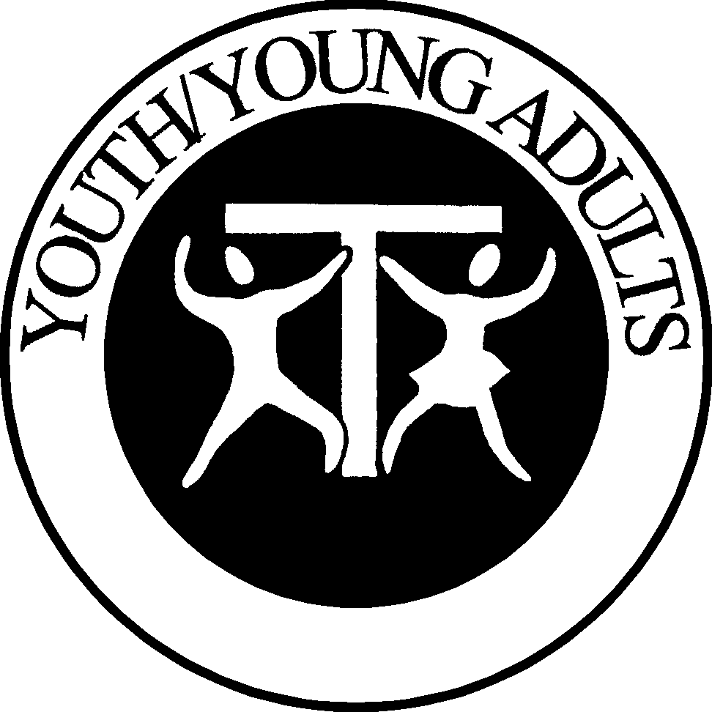

Report of the National Franciscan Youth/Young Adult Commission to the NaFra.
Meeting held in Plymouth, MI from October 19 to 24, 2004.
This report covers the activities of the Commission from October 2003 to September 2004.

Annual Meetings: Our annual meeting was held in January 2004 at the Franciscan University in Steubenville, Ohio, the residence of Br. Jim. All members of the Y/YA were present – Kathy Taormina, SFO, Jeanie McLees, SFO, Vivian Weaver, SFO and Br. James Boyle, TOR. The next annual meeting will be held from January 14 to 17, 2005 in Pittsburgh, Pennsylvania.

Announcements:
May 18, 2004: Queen of Peace Region appointed the first USA Regional YYA Commission Chair who is a young adult, Elizabeth Taormina, SFO. At the age of 23, she is the first profession for the newly re-established fraternity of Blessed Pope John XXIII, SFO fraternity located in the Twin Cities of Minnesota.
August 29, 2004: Dale Anesi, SFO from St. Francis Region in California was appointed to serve on the Commission, rounding out the team at five members.

All Commissions Conference: The members of the YYA all contributed and were involved during the ACC in June. We also asked two SFO members who are actively involved with youth and SFO leadership to speak on “Passion for youth where they are” and “What do I do now?” - Rock DeSpain, SFO and Sandra Morgan, SFO. We took into consideration the last ACC evaluations and planned accordingly with more “hands-on” time and sharing time. The registration and an YYA pre-letter were sent to all the Regional Chairs, which were identified, to guarantee the information flow and to promote interest. A second letter updating the regional YYA chairs was mailed along with pertinent things to bring to the sessions. We had 32 participants registered for the YYA sessions, which included 15 “official” regional commission chairs; only 6 regions were missing. The youth/young adults from the Blessed Pope John XXIII, SFO fraternity in Minnesota painted the flames on the 271 TAU cross gifts.

“Charter for the Protection of Children and Young People” (NCCB): was researched, read and discussed at our annual meeting. The commission has decided to take a pro-active stance and is in the process of drafting an informational document for all who work with Franciscan Youth. We will wait until the CMSM (Council for Major Superiors of Men) have their document finished and in place for the Orders of men, and then we will draft ours accordingly. In the meantime, we on the National Commission have had our Criminal Background Checks completed. We believe we have to “Walk the Walk to Talk the Talk”!

Conferences:
National Catholic Family Conference, August 21-22, 2004 – I attended this conference in Anaheim, California to get ideas on how to plan and facilitate a conference with families and youth attending. I was accompanied by Dale Anesi, SFO from the YYA Commission and Eileen Costa, SFO who is the St. Francis Region’s YYA Commission Chair. Diane Halal, SFO was also present.
National Conference on Catholic Youth Ministers, December 1-5, 2004 – I will attend this and the Itinerant Ministers Retreat Day along with Vivian Weaver, SFO from the YYA Commission in Pittsburgh, PA. I have become a Charter Member of the NACYML for one year.

Contacts: I have been in contact with Br. David Liedl, TOR in the Twin Cities area about “Catholic Volunteers in Florida”. It is a Franciscan based youth volunteer opportunity for a year of service. Because of this contact we are talking about combining efforts for the Franciscan youth in the area between the TOR and SFO branches of the family. I have also contacted Br. Jim Moore, OFM Conv., in Syracuse, NY about “FrancisCorps”, a similar Franciscan lay volunteer experience for youth. Both program leaflets were available at the YYA sessions at the ACC. I have been invited to speak to college youth and young Franciscans at Marian College in Indianapolis, Indiana by Robert W. Golobish, APR, Vice President of Marketing Communications. He is currently in SFO formation.

Franciscan World Youth Days 2005: will be held during the International World Youth Day in Cologne, Germany in the summer of 2005 from August 12-15, 2005. Fr. Ivan Matik’, OFM, the International Spiritual Assistant who oversees the Franciscan Youth, has contacted me and will keep me abreast of the upcoming event. The web page will contain all the up-dated information as we receive it. The proposal for sending USA delegates was discussed and approved during the EC meeting in June in Denver. The instructions on how to obtain a scholarship of $500.00 to be used toward a WYD participant’s trip to Germany, and thus, be named as one of three delegates, were published in the TAU-USA and on the NaFra list service. It was also emailed to all Regional Youth/Young Adult Commission Chairs and to all the ACC Youth/Young Adult session participants. As of this writing, no essays have been received.

A Guide for Franciscan Youth/Young Adult Ministry: 2004 revision is finished! A first-run of 50 copies were made for the ACC in June in Denver. They were sold there at the special ACC price of only $7.00. It will continue to be printed by Barbo-Carlson and the cost will remain at the previous $10.00.

Speaking Invitations:
April 28, 2004 I spoke on the subject of “Parenting Today” to parents from the CCD program in Hilton Head Island, South Carolina. This was facilitated by an SFO fraternity from the Brothers and Sisters of St. Francis Region.
November 20, 2004 I will present on the subject of Franciscan Youth in Tampa, Florida to the Five Franciscan Martyrs Region.

TAU-USA National Newsletter: The first and second installments of the 2004 TAU-USA Y/YA formation articles were written by me; and the next two articles will be co-written with the other Commission members. The articles will be available on the web page.

Web Page: is located at www.franciscanyouthusa.com . It has been received with many compliments and suggestions. The bios and photos of the YYA Commission have been added for easy identification and background information. It is constantly updated, thanks to our web servant, Vivian Weaver. It has already proven to be an indispensable tool for the YYA to disburse information and foster enthusiasm.

Respectfully submitted on September 19, 2004 by:
Kathy Taormina, sfo
National Chair

