NEWS
NATIONAL FRATERNITY
SECULAR FRANCISCAN ORDER
IN THE UNITED STATES

Media Contact:
Mary Stronach, SFO, 315-796-9284; Bob Stronach, SFO, 315-796-9468; stronach@kateriregion.org

FOR IMMEDIATE RELEASE: Oct. 24, 2009

THUMAN ATTENDS NATIONAL GATHERING
Secular Franciscans Select New Regional Minister
In St. Margaret of Cortona Region in MD, DC, DE, VA

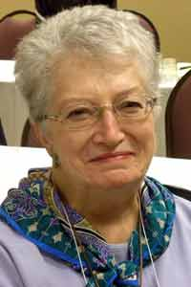
BALTIMORE, MD – Mary Thuman of Baltimore, MD was recently selected Regional Minister of St. Margaret of Cortona Region of The Secular Franciscan Order (SFO) in Maryland, the District of Columbia, Delaware and Virginia.

Representing fraternities in the region, she participated in the order’s national gathering held in Albuquerque, NM from Oct. 20 to 25.

Thuman is a member of Little Flower Fraternity in Baltimore, MD where she has served as minister, vice-minister, secretary and formation director. On the regional level, she has served as minister. She was professed in 1983.

Professionally, Thuman has worked as Secretary at Barco Trucking, executive assistant at Goodwill Industries of Chesapeake; Customer Advocate at Success for All, Inc.; receptionist at Hampton Plaza and Chaplain at Good Samaritan Hospital.

Among Thuman’s community activities are: den mother in the Boy Scouts, Renew and RCIA coordinator, president of the Parish Council of St. Dominic’s Parish, lector and Eucharistic Minister with her husband at Hamilton Genesis Nursing Home.

Thuman has been married to her husband Bob for 49 years. They have five children, Tom, Kathy Chenowith, Bob, Joe and Glenn, and eleven grandchildren.

The Secular Franciscan Order is an order of lay men and women, single and married, founded by St. Francis of Assisi. For more information about the SFO, call 1-800-Francis or go on-line to NAFRA-SFO.ORG.
# # #

