NEWS
NATIONAL FRATERNITY
SECULAR FRANCISCAN ORDER
IN THE UNITED STATES

Media Contact:
Mary Stronach, SFO, 315-796-9284; Bob Stronach, SFO, 315-796-9468; stronach@kateriregion.org

FOR IMMEDIATE RELEASE: Oct. 24, 2009

ENSIGN ATTENDS NATIONAL MEETING
Secular Franciscans Select New Regional Minister
In Divine Mercy Region in Michigan and Ohio

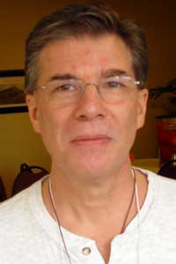
SPRING LAKE, MI – Roger Ensign of Spring Lake, MI was recently selected Regional Minister of Divine Mercy Region of The Secular Franciscan Order (SFO) in Lower Michigan and Toledo, OH.

Representing fraternities in the region, he participated in the order’s national gathering held in Albuquerque, NM from Oct. 20 to 25.

Ensign is a member of St. Elizabeth of Portugal Fraternity in Spring Lake, MI . He served as minister, vice-minister, and formation director for his previous fraternity, St. Isidore in Grand Rapids, MI. On the regional level, he has served as vice-minister and councilor. He was professed in 1997.

Ensign works as an installation coordinator for Stiles Machinery in Grand Rapids, MI.

Ensign is a member of St. Mary’s Parish in Spring Lake. He has been an RCIA catechist and pastoral council chair.

Ensign has been married to his wife Toni Ann for 35 years. They have two sons and daughters-in-law, Shaun and Rebecca, and Ryan and Heather.

The Secular Franciscan Order is an order of lay men and women, single and married, founded by St. Francis of Assisi. For more information about the SFO, call 1-800-Francis or go on-line to NAFRA-SFO.ORG.
# # #

