NEWS
NATIONAL FRATERNITY
SECULAR FRANCISCAN ORDER
IN THE UNITED STATES

Media Contact:
Mary Stronach, SFO, 315-796-9284; Bob Stronach, SFO, 315-796-9468; stronach@kateriregion.org

FOR IMMEDIATE RELEASE: Oct. 24, 2009

Minister of Our Lady of Angels Region (Northern NJ & Southern NY)
Participates in National Secular Franciscan Gathering in New Mexico

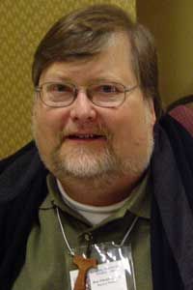
CLIFTON, NJ – Ronald Pihokker of Clifton, NJ, Regional Minister of Our Lady of Angels Region of The Secular Franciscan Order (SFO), participated in the order’s national gathering held in Albuquerque, NM from Oct. 20 to 25. He represented fraternities in Northern New Jersey, plus Manhattan, Staten Island, Yonkers and South Westchester County in New York.

Pihokker is a member of Most Holy Name in Little Falls, NJ where he has served as minister, vice minister and formation director. On the regional level, he has served as minister and formation director. He has also served on the national level as national vice minister and chairman of the national formation commission. He was professed in 1977.

Professionally, Pihokker works with the Archdiocese of Newark as director of the catechetical office. Pihokker is also a member of the Evangelization Commission, Liturgical Commission and Antipoverty Task Force of the Archdiocese of Newark.

Pihokker lives with his wife of 33 years, Jody. She is also a Secular Franciscan. They have two children, Kristen and Matthew.

The Secular Franciscan Order is an order of lay men and women, single and married, founded by St. Francis of Assisi. For more information about the SFO, call 1-800-Francis or go on-line to NAFRA-SFO.ORG.
# # #

