NEWS
NATIONAL FRATERNITY
SECULAR FRANCISCAN ORDER
IN THE UNITED STATES

Media Contact:
Mary Stronach, SFO, 315-796-9284; Bob Stronach, SFO, 315-796-9468; stronach@kateriregion.org

FOR IMMEDIATE RELEASE: Oct. 24, 2009

Simeone Participates in National Gathering
Secular Franciscans Select New Regional Minister
In St. Thomas More Region in Arizona & Nevada

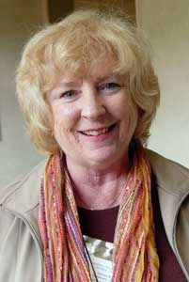
PHOENIX, AZ – Susan Simeone, EdD, SFO, of Phoenix, AZ is the new Regional Minister of St. Thomas More Region of The Secular Franciscan Order (SFO) in Arizona and Las Vegas, Nevada.

Representing fraternities in the region, she attended the order’s national gathering held in Albuquerque, NM from Oct. 20 to 25.

Simeone is a member of St. Clare Fraternity in Phoenix where she has served as minister, vice-minister, newsletter editor and a member of the formation team. On the regional level, she has served as vice minister. She was professed in 2000.

Professionally, Simeone has worked at all levels of education – elementary, high school and university as teacher, administrator, curriculum director, and educational consultant.

Among Simeone’s community activities are: Eucharistic Minister, lector, bereavement ministry, volunteer puppy raiser for Power Paws, Inc. (service dogs), volunteer on the Pet Therapy team for a local hospital, and presenter at education conferences and workshops.

Simeone lives with her husband Phil who is also a Secular Franciscan and Deacon. They have one daughter, Claire.

The Secular Franciscan Order is an order of lay men and women, single and married, founded by St. Francis of Assisi. For more information about the SFO, call 1-800-Francis or go on-line to NAFRA-SFO.ORG.

