NEWS
NATIONAL FRATERNITY
SECULAR FRANCISCAN ORDER
IN THE UNITED STATES

Media Contact:
Mary Stronach, SFO, 315-796-9284; Bob Stronach, SFO, 315-796-9468; stronach@kateriregion.org

FOR IMMEDIATE RELEASE: Oct. 24, 2009

HADDAD ATTENDS NATIONAL MEETING
Secular Franciscans Select New Regional Minister
For Father Solanus Casey Region in CT, RI, MA, NY

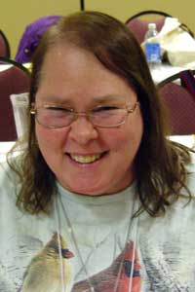
Berlin, CT -- Sally Haddad of Berlin, CT is the new Regional Minister of Father Solanus Casey Region of The Secular Franciscan Order (SFO) in Connecticut, Rhode Island, Lower Massachusetts and the Hudson area of New York.

Representing fraternities in the region, she participated in the order’s national gathering held in Albuquerque, NM from Oct. 20 to 25.

Haddad is a member of St. Pius X Fraternity in Middletown, CT where she has been secretary, vice-minister and director of formation. On the regional level, she has served as secretary, district councilor and work commission chairperson. At the national level, she worked as Work Commission chair. She was professed in 1986.

She has also taught RCIA and has made comfort hats for women who lose their hair from chemotherapy.

For the past 36 years Haddad has worked for Electric Boat as a pipe designer.

Haddad lives in Berlin with her husband, Chuck.

The Secular Franciscan Order is an order of lay men and women, single and married, founded by St. Francis of Assisi. For more information about the SFO, call 1-800-Francis or go on-line to NAFRA-SFO.ORG.
# # #

