NEWS
NATIONAL FRATERNITY
SECULAR FRANCISCAN ORDER
IN THE UNITED STATES

Media Contact:
Bob Stronach, SFO, 315-796-9468; Mary Stronach, SFO, 315-796-9284, stronach@bktr.org

FOR IMMEDIATE RELEASE: Nov. 9, 2011

Friar Receives National 'Justice, Peace & Integrity of Creation' Award

Fr. Louie Vitale, OFM, a Franciscan friar known for protests against war and torture and advocacy for the poor, is the recipient of the U.S. Secular Franciscan Order's Justice, Peace and Integrity of Creation Award.

The award was presented at the order's recent national chapter at St. Francis Retreat Center in San Juan Bautista, CA.

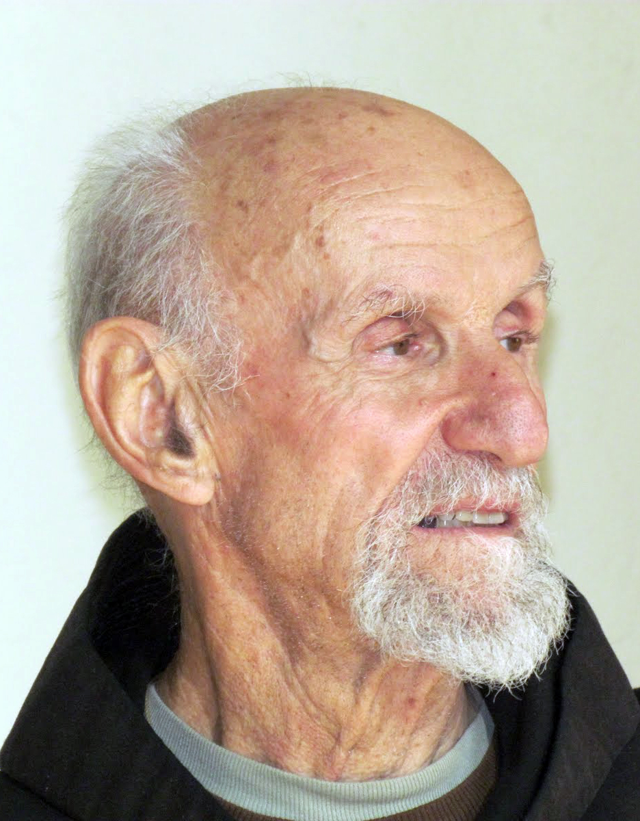
Formerly known as the Peace Award, it was "renamed this year to capture the significant efforts in the areas of justice, peace and the integrity of creation," noted Award Chairman Kent Ferris, SFO, who also chairs the order's Justice, Peace & Integrity of Creation (JPIC) Commission. "Our Franciscan Rule reminds us of our responsibility to 'individually and collectively be in the forefront of promoting justice by the testimony of our lives.' The JPIC Award allows us to recognize those who have modeled such courageous efforts."

Letters of nomination, Ferris noted, spoke not only of the issues Father Louie has focused on -- such as nuclear disarmament, School of Americas watch, and torture -- but also on his personal lived experience. "Father Louie is the ultimate model for us on our journey of following in the footsteps of Saints Francis and Clare," he quoted one letter. And in another, “Father Louie sees each and every person as part of the Integrity of Creation and a gift from our Loving God as a path towards humbled holiness.”

Fr. Louie Vitale, 79, who resides at St. Elizabeth Church in Oakland, CA, is an Air Force veteran who became a Franciscan friar. He co-founded the Nevadea Desert Experience, a movement to end nuclear testing, and Pace e Bene, an organization that aims to transform lives through education and nonviolent action for social change. He travels extensively throughout the United States speaking on nonviolence, the moral dimensions of torture and drone warfare, and living as a peacemaker.

He holds a Ph.D. is sociology, and has taught classes at colleges and universities throughout the Western states. He has served as provincial of the Franciscan Friars' Santa Barbara Province, and for more than a decade, he was pastor of St. Boniface Church in a low-income neighborhood in San Francisco, CA, where he opened its doors to the homeless so they could sleep in the pews during the day.
Father Louie has engaged in civil disobedience for some four decades in pursuit of peace and justice. He has been arrested an estimated 300 times standing up against war, nuclear weapons, drones, and the training of Latin American soldiers at what was formerly called the U.S. Army's School of the Americas.
The Justice, Peace and Integrity of Creation Award comes with a St. Francis statue and a $2,000 prize.

The annual award was revived in 2007 after a lapse of several years. The 2007 award recognized the work of Dr. Tony Lazzara, an American physician and Secular Franciscan who operates a clinic and shelter for ailing children in Peru. The 2008 award honored Marie Dennis, a Secular Franciscan who directs the Maryknoll Office for Global Concerns and who is immersed in advocating on behalf of people marginalized by society, poverty, abuse, war, violence, and human trafficking. The 2009 award went to Don Ryder, a Secular Franciscan from Wisconsin who helped save the Maasai people in Kenya from disease and drought by drilling water wells. Last year it honored Br. David Bauer, OFM, for his work with the homeless and marginalized in Tuscon and Las Vegas. Among the more notable prior recipients were the Rev. Dr. Martin Luther King Jr. and Mother Teresa of Calcutta.

The Secular Franciscan Order is an order of single and married Catholics who profess to bring the Gospel to life in the spirit of St. Francis.

###

