NEWS
NATIONAL FRATERNITY
SECULAR FRANCISCAN ORDER
IN THE UNITED STATES

Media Contact: Robert Stronach, SFO, 315-796-9468, stronach@kateriregion.org

FOR IMMEDIATE RELEASE: Nov. 5, 2008

Florida Man Heads Secular Franciscan Region
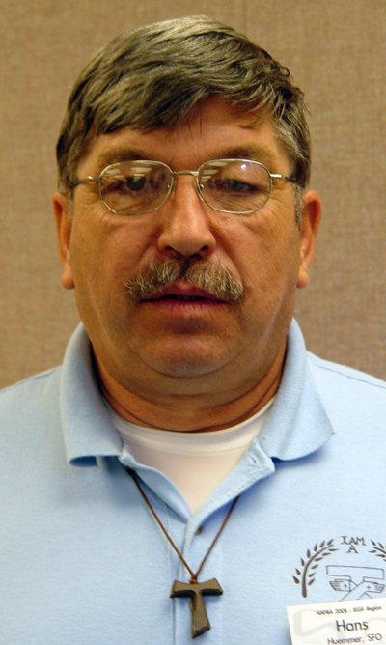
Hans D. Huemmer, SFO, of Casselberry, FL, is the new minister of the Secular Franciscan Order’s Five Franciscan Martyrs Region.

Representing fraternities in the region, he attended the order’s national gathering held at the Scarritt-Bennett Center in Nashville, TN from Oct. 14 to 19.

Huemmer is a member of Lady Poverty Fraternity in Winterpark, FL. Prior to being elected regional minister, he served in a number of positions in his local fraternity.

In his professional life, he is a trades tech for Orange County School Board.

He is married to Suzanne Huemmer.

###

