NEWS
NATIONAL FRATERNITY
SECULAR FRANCISCAN ORDER
IN THE UNITED STATES

Media Contact: Robert Stronach, SFO, 315-796-9468, stronach@kateriregion.org

FOR IMMEDIATE RELEASE: Nov. 5, 2008

Colorado Woman Heads Secular Franciscan Region
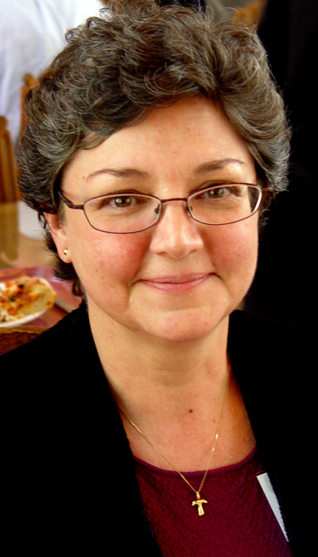
Mary Anne Lenzi, SFO, of Centennial, CO, is the new minister of the Secular Franciscan Order’s Santa Maria de las Montanas Region. Representing fraternities in her region, she attended the order’s national gathering held at the Scarritt-Bennett Center in Nashville, TN from Oct. 14 to 19.

Lenzi is a member of St. Clare Fraternity, Denver, CO. Prior to being elected regional minister, she served as vice minister of her region and as minister of her local fraternity.

Currently a legal assistant, Lenzi has worked in the legal field for most of her career. She holds a master's degree in social work and also worked in the area of health and mental health, particularly with geriatric populations.

She is a Eucharistic minister at St. Thomas More Parish and a member of the Stephen Ministries Team..

###

