NEWS
NATIONAL FRATERNITY
SECULAR FRANCISCAN ORDER
IN THE UNITED STATES

Media Contact: Robert Stronach, SFO, 315-796-9468, stronach@kateriregion.org

FOR IMMEDIATE RELEASE: Nov. 5, 2008

Connecticut Woman Heads Secular Franciscan Region
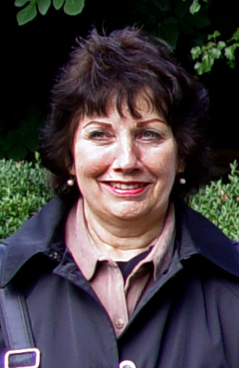
Mary Lou Scebelo, SFO, of New Fairfield, CT, is the new minister of the Secular Franciscan Order’s Fr. Solanus Casey Region. Representing fraternities in the region, she attended the order’s national gathering held at the Scarritt-Bennett Center in Nashville, TN from Oct. 14 to 19.

Scebelo is a member of Sacred Heart of Jesus Fraternity in Danbury, CT. Prior to being elected regional minister, she served as regional vice minister and as minister, vice minister, formation director and secretary of her local fraternity.

She has worked as a medical secretary and maintains a real estate license.

At St. Edward the Confessor Parish in New Fairfield, she serves as Eucharistic minister and lector and co-leads Glory & Praise Gatherings and workshops.

Scebelo and her husband, Tom, have three sons and a granddaughter.

###

