NEWS
NATIONAL FRATERNITY
SECULAR FRANCISCAN ORDER
IN THE UNITED STATES

Media Contact: Robert Stronach, SFO, 315-796-9468, stronach@kateriregion.org

FOR IMMEDIATE RELEASE: Nov. 5, 2008

California Woman Heads Secular Franciscan Region
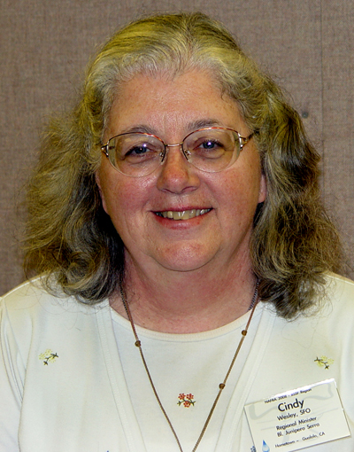
Cindy Wesley, SFO, of Gualala, CA, is the new minister of the Secular Franciscan Order’s Bl. Junipero Serra Region. Representing fraternities in her region, she attended the order’s national gathering held at the Scarritt-Bennett Center in Nashville, TN from Oct. 14 to 19.

Wesley is a member of Il Poverello Fraternity in Sebastopol, CA. Prior to being elected regional minister, she served on her local fraternity council and also was responsible for the regional database and directory, which she continues to oversee.

A teacher, Wesley is active in music ministry in her parish and serves on her parish steering committee.

She and her husband, Jim, who is also a Secular Franciscan, have three daughters.

###

